B.Sc Physics (Major)

Semester I

Physics Core Course 2

**Mechanics**

**Laboratory Notebook**

Roll Number : 1810093104502

Registration Number : 0091805030584

Session : 2018-2019

INDEX

|  |  |  |
| --- | --- | --- |
| Exp. No. | Title | Page |
| 1. | Determination of Acceleration due to Gravity (‘g’) using Kater’s Pendulum. | 1 |
| 2. | Determination of Acceleration due to Gravity (‘g’) using Bar Pendulum. | 3 |
| 3. | Determination of the Young’s Modulus of the Material of a wire by Searle’s Method. | 5 |
| 4. | Determination of the Spring Constant of a given Spring | 7 |
| 5. | Measuring the length of a given rod using Vernier Calipers | 9 |
| 6. | Measuring the Diameter and Radius of a given rod using Screw Gauge | 10 |
| 7. | Measuring the Diameter and Radius of a given rod using Traveling Microscope Tube | 11 |
| 8. | Measuring the Diameter and Radius of a Capillary Tube using Traveling Microscope Tube | 13 |
| 9. | Determining the Modulus of Rigidity of the Material of a wire by Maxwell’s Needle | 15 |

Experiment No. 1 :

**Determination of Acceleration due to Gravity (‘g’) using Kater’s Pendulum**

**Theory:** From the theory of compound pendulum we know that, , where T is the time period of oscillation, k is the radius of gyration about the center of mass, r is the distance between point of suspension and the center of gravity.

In case of Kater’s Pendulum, if the time period of oscillation for two different point of suspension be T1 and T2 and T1 and T2 are very close. If r1 andr2 be the distance between the point of suspension and the center of gravity in case of the previous two different point of suspension.

So, and

We can deduct from the above equation that,

, this the working formula for this experiment.

**Apparatus:** i) Kater’s Pendulum, ii) Stop Watch, iii) Meter Scale, iv) Wedge, v) Telescope

**Experiment:**

1. Adjusting the cylindrical masses to get a nearly equal T1 and T2.

Table :

|  |  |  |  |  |
| --- | --- | --- | --- | --- |
| No. | Cylinder | No. of Oscillations considered | Total Time Period of oscillations (sec) | |
| K1 | K2 |
| 1. | D | 5 | 8.81 | 8.87 |
| 2. | D | 5 | 8.71 | 8.77 |
| 3. | D | 10 | 18.01 | 17.09 |
| 4. | D | 10 | 17.82 | 17.71 |
| 5. | D | 20 | 35.50 | 35.42 |

1. Determining the final time period of oscillation T1 and T2

|  |  |  |  |  |
| --- | --- | --- | --- | --- |
| No. | Observed about the knife-edge | Time Period for 50 Oscillations (sec) | Mean Time Period for 50 Oscillations (sec) | Time Period (sec) |
| 1. | K1 | 88.05 | 87.48 | 1.7496 (T1) |
| 2. | 87.40 |
| 3. | 86.99 |
| 1. | K2 | 86.89 | 87.47 | 1.7494 (T2) |
| 2. | 87.47 |
| 3. | 88.05 |

1. Determining the r1 and r2

|  |  |  |  |  |
| --- | --- | --- | --- | --- |
| No. | Distance between K1 and C.G.  r1 (cm.) | Mean r1 (cm.) | Distance between K2 and C.G.  r2 (cm.) | Mean r2 (cm.) |
| 1. | 44.2 | 44.1666 | 31.6 | 31.6333 |
| 2. | 44.1 | 31.7 |
| 3. | 44.2 | 31.6 |

Calculations :

T1 = 1.7496 sec.; T2 = 1.7494 sec.

r1 = 44.1666 cm.; r2 = 31.6333 cm.

So we’ve calculated that the local acceleration due to gravity is 977.12 cm-s-2

**Conclusion:** i) The plane on which the knife-edge is placed, must have to horizontal.

ii) This experiment is very sensitive as it seems. A small change results in a big difference in final result. So we need to take measurement more carefully and with more digital measuring instruments.

Experiment No. 2 :

**Determination of Acceleration due to Gravity (‘g’) using Bar Pendulum**

**Theory:** From the theory of compound pendulum we know that, , where T is the time period of oscillation, k is the radius of gyration about the center of mass, r is the center of gravity. Where the term is also known as Reduced Length. We can also show that this Reduced Length (L) is equal to the distance between the two specific points of suspension where the time period of oscillation is same.

In case of Bar Pendulum, for two equal T1 and T2. So the equation reduces to the legendary form, .

So, , these are the working formula for this experiment.

**Apparatus:** i) Bar Pendulum, ii) Stop Watch, iii) Meter Scale, iv) Knife-Edge

**Experiment:** Recording values of Time Period for different r.

Table :

|  |  |  |  |  |
| --- | --- | --- | --- | --- |
| No. | Which End | Distance to the point of suspension from the end point (cm.) | Total Time Period for 30 Oscillations (sec.) | Time Period (sec.) |
| 1. | End 1 | 5 | 49.2 | 1.64 |
| 2. | 10 | 46.8 | 1.56 |
| 3. | 15 | 46.2 | 1.54 |
| 4. | 20 | 45.6 | 1.52 |
| 5. | 25 | 46.2 | 1.54 |
| 6. | 30 | 47.4 | 1.58 |
| 7. | 35 | 48.6 | 1.62 |
| 8. | 40 | 59.7 | 1.99 |
| 9. | 45 | 82.5 | 2.75 |
| 10. | End 2 | 5 | 82.5 | 2.75 |
| 11. | 10 | 59.7 | 1.99 |
| 12. | 15 | 48.6 | 1.62 |
| 13. | 20 | 47.4 | 1.58 |
| 14. | 25 | 46.2 | 1.54 |
| 15. | 30 | 45.6 | 1.52 |
| 16. | 35 | 46.2 | 1.54 |
| 17. | 40 | 46.8 | 1.56 |
| 18. | 45 | 49.2 | 1.64 |

Graph : 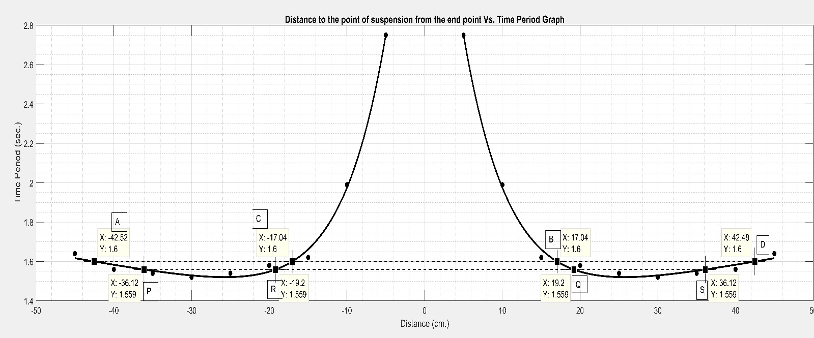

Calculation : Observation from the graph

Case 1 : Time Period = 1.6 sec.

AB = 59.56 cm ; CD = 59.52

L = 59.54 cm

T = 1.6 sec

918.1816 cm.-sec.-2

Case 2 : Time Period = 1.559 sec

PQ = 55.32 cm ; RS = 55.32 cm

L = 55.32 cm

T = 1.559 sec.

g = 898.5654 cm.-sec.-2

So average cm-s-2

So we’ve calculated that the local acceleration due to gravity is 908.3735 cm-s-2

**Conclusion:** i) The plane on which the knife-edge is placed, must have to horizontal.

ii) Amplitude should be small.

iii) The Pendulum must not rotate about the vertical axis.

ii) This experiment is very sensitive as it seems. A small change results in a big difference in final result. So we need to take measurement more carefully and with more digital measuring instruments.

Experiment No. 3 :

**Determination of the Young’s Modulus of the Material of a wire by Searle’s Method**

**Theory:** We know that the Young’s Modulus of a wire is given by,

………….equation 1

Where, Y = Young’s Modulus l = initial length of the wire (before attaching mass)

m = attached mass Δl = change in length (after attaching mass)

g = acceleration due to gravity Δl = lf – li

d = diameter of the wire

We can write equation 1 as,

……………..equation 2

So, by plotting (Δl, m) and calculating the slope of the line, we can calculate Y as,

where is the slope. This will be the working formula of this experiment.

**Apparatus:** i) Experimental Wire, ii) Reference Wire, iii) Leveler, iv) Various Weights,

**Experiment:** Determining the slope of the equation 2

Table :

|  |  |  |  |  |  |  |  |  |  |
| --- | --- | --- | --- | --- | --- | --- | --- | --- | --- |
| No. | Extra Load over Dead Load (kg) | While Increasing Load | | | While Decreasing Load | | | Average Length (cm) | Elongation (cm) |
| Reading of Linear Scale (L) (cm) | Reading of Circular Scale (C) (div) | Total Length (L+C*S.P.) (cm) | Reading of Linear Scale (L) (cm) | Reading of Circular Scale (C) (div) | Total Length (L+C*S.P.) (cm) |
| 1 | 0 | 0 | 5 | 0 | 0 | 15 | 0.01 | 0.005 | - |
| 2 | 1 | 0 | 58 | 0.058 | 0 | 52 | 0.047 | 0.05 | 0.045 |
| 3 | 2 | 1 | 2 | 0.097 | 0 | 98 | 0.093 | 0.095 | 0.090 |
| 4 | 3 | 1 | 47 | 1.042 | 1 | 33 | 1.028 | 0.135 | 0.13 |
| 5 | 4 | 2 | 3 | 1.098 | 1 | 80 | 1.075 | 0.186 | 0.181 |
| 6 | 5 | 2 | 97 | 2.097 | 2 | 97 | 2.092 | 0.292 | 0.287 |

Graph:

Table for plotting the graph:

|  |  |  |  |  |  |  |
| --- | --- | --- | --- | --- | --- | --- |
| x axis (Load) [kg] | 0 | 1 | 2 | 3 | 4 | 5 |
| y axis (Elongation) [cm] | 0 | 0.045 | 0.090 | 0.13 | 0.181 | 0.287 |



Calculation: The point specified in the graph is (40.2017)

Therefore, slope of the line is,

Given data : Length of the wire (l) = 154 cm.

Diameter of the wire = 0.051 cm.

Therefore,

= 14.6 x 1011 dyne-cm-2

So, we’ve calculated the Young’s Modulus of the wire which is 14.6 x 1011 dyne-cm-2

**Conclusion:** i) Sarle’s Method is a very effective way to measure the Young’s Modulus of the material of the wire.

ii) Since attached mass and elongation has a linear relationship, so we have a minimum instrumental error. Which is good.

Experiment No. 4 :

**Determination of the Spring Constant of a given Spring**

**Theory:** From Hook’s Law we know that, within elastic limit, , where Fapplied is the amount of Force applied on the spring and Δl is the change in length. The previous equation can be written as . Here k is known as the Spring Constant of the spring which we have to find out.

; M is the mass attached to the spring

; where i.e. mass needed for a unit elongation

This formula will be the working formula for this experiment.

**Apparatus:** i) Spring, ii) Mass Scale, iii) Meter Scale, iv) Weights

**Experiment:**

Table:

|  |  |  |  |  |  |
| --- | --- | --- | --- | --- | --- |
| No. | Attached Load (g) | Elongated Length (cm) | | | Elongation (cm) |
| While Loading | While Unloading | Mean |
| 1. | 0 | 23 | 23 | 23 | - |
| 2. | 50 | 23.8 | 23.8 | 23.8 | .8 |
| 3. | 100 | 24.8 | 24.8 | 24.8 | 1.8 |
| 4. | 150 | 26.1 | 26.2 | 26.15 | 3.15 |
| 5. | 200 | 27.4 | 27.4 | 27.4 | 4.4 |

Graph:

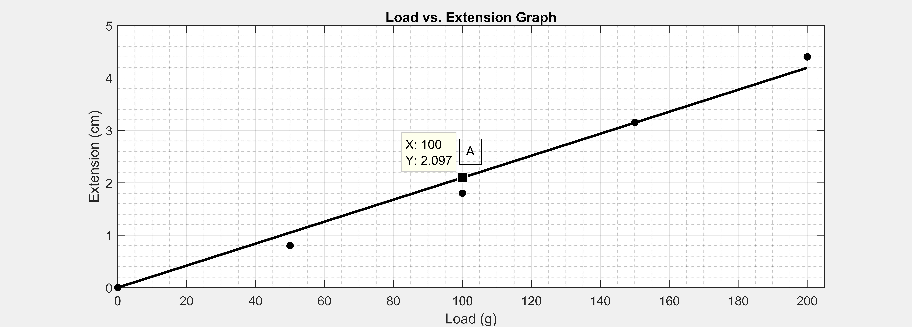

Calculation: Observation from graph

The graph is between M and Δl. The straight line follows the equation .

The point A on the graph is (100,2.097)

Therefore the slope of the graph is =

So,

Therefore,

; g=981 cm-s-2

So we’ve calculated the spring constant to be around 46781.11 dyne-cm-2

**Conclusion:** i) While performing the experiment the spring must not be oscillating.

ii) A simple linear relationship makes this measurement very immune to instrumental errors.

Experiment No. 5 :

**Measuring the length of a given rod using Vernier Calipers**

**Theory:** To measure a length using Vernier Calipers, we need to record two consecutive readings, one is the Main Scale Reading and the other one is the Vernier Scale Reading. Every Vernier Calipers has a characteristic parameter called Vernier Constant which is the difference between one main scale division and one Vernier scale division.

VC = 1MSD – 1VSD

Now, the final reading is, MSR + VSR * VC, where MSR stands for Main Scale Reading, VSR stands for Vernier Scale Reading.

**Apparatus:** i) Vernier Calipers

**Experiment:**

1. Calculating Vernier Constant

1 MSD = 0.1 cm.

10 VSD = 9 MSD

= 0.9 cm.

1 VSD = 0.09 cm.

VC = 0.1 – 0.09 cm.

= 0.01 cm

1. Measuring the Length

Table:

|  |  |  |  |  |
| --- | --- | --- | --- | --- |
| No. | MSR (cm) | VSR (div) | Length (cm) | Mean Length (cm) |
| 1. | 9.8 | 9 | 9.89 | 9.238 |
| 2. | 8.7 | 8 | 8.78 |
| 3. | 9.1 | 7 | 9.17 |
| 4. | 9.2 | 9 | 9.29 |
| 5. | 9.3 | 8 | 9.38 |

So we’ve measured the length to be 9.238 ± 0.01cm.

**Conclusion:** i) The Vernier Calipers has an absolute error of 0.01 cm.

ii) The Vernier Calipers has no zero error.

iii) We’ve executed the experiment several times to get more accurate results.

Experiment No. 6 :

**Measuring the Diameter and Radius of a given rod using Screw Gauge**

**Theory:** To measure a length using Screw Gauge, we need to record two consecutive readings, one is the Main Scale Reading and the other one is the Circular Scale Reading. Every Screw Gauge has a characteristic parameter called Screw Pitch and Least Count.

Reading = MSR + CSR*LC, where MSR stands for Main Scale Reading, CSR stands for Circular Scale Reading and LC stands for Least Count

**Apparatus:** i) Screw Gauge

**Experiment:**

Screw Pitch = 1mm

Total Number of divisions in the Circular Scale = 100 div

So, Least Count = 1/100 mm./div.

= 0.01 mm./div.

Table:

|  |  |  |  |  |
| --- | --- | --- | --- | --- |
| No. | MSR (mm) | CSR (div) | Total Reading (mm) | Average Diameter (mm) |
| 1. | 9 | 34 | 9.34 | 9.347 |
| 2. | 9 | 35 | 9.35 |
| 3. | 9 | 35 | 9.35 |

So, we’ve calculated the diameter of the rod is 9.347 ± 0.01 mm.

So, the radius of the rod is 4.6735 ± 0.01 mm.

**Conclusion:** i) The Screw Gauge has an absolute error of 0.001 cm.

ii) The Screw Gauge has no zero error.

iii) We’ve executed the experiment several times to get more accurate results.

Experiment No. 7:

**Measuring the Diameter and Radius of a given rod using Traveling Microscope Tube**

**Theory:** Its principal of operation is based on that of the Vernier Calipers. To measure a small length, we need to record two consecutive readings, one is the Main Scale Reading and the other one is the Vernier Scale Reading. Every Vernier Calipers has a characteristic parameter called Vernier Constant which is the difference between one main scale division and one Vernier scale division.

VC = 1MSD – 1VSD

Now, the final reading is, MSR + VSR * VC, where MSR stands for Main Scale Reading, VSR stands for Vernier Scale Reading.

**Apparatus:** i) Traveling Microscope Tube

**Experiment:**

1 MSD = 0.05 cm.

50 VSD = 49 MSD

1 VSD = 49/50 MSD

= 0.049 cm.

VC = 0.05-0.049 cm.

= 0.001 cm.

Table:

1. Measuring the diameter horizontally

|  |  |  |  |  |  |  |  |  |
| --- | --- | --- | --- | --- | --- | --- | --- | --- |
| No. | Right Side | | | Left Side | | | Diameter (cm) | Average (cm) |
| MSR (cm) | VSR (div) | Reading (cm) | MSR (cm) | VSR (div) | Reading (cm) |
| 1. | 5.4 | 0 | 5.40 | 4.45 | 22 | 4.472 | 0.928 | 0.9823 |
| 2. | 5.4 | 3 | 5.403 | 4.45 | 20 | 4.470 | 0.933 |
| 3. | 5.4 | 5 | 5.405 | 4.45 | 19 | 4.469 | 0.936 |

1. Measuring the diameter vertically

|  |  |  |  |  |  |  |  |  |
| --- | --- | --- | --- | --- | --- | --- | --- | --- |
| No. | Up | | | Down | | | Diameter (cm) | Average (cm) |
| MSR (cm) | VSR (div) | Reading (cm) | MSR (cm) | VSR (div) | Reading (cm) |
| 1. | 8.2 | 10 | 8.210 | 7.25 | 30 | 7.280 | 0.930 | 0.9327 |
| 2. | 8.2 | 8 | 8.208 | 7.25 | 27 | 7.277 | 0.931 |
| 3. | 8.2 | 12 | 8.212 | 7.25 | 25 | 7.275 | 0.937 |

Average Diameter = (0.9823+0.9327)/2

= 0.9325 cm.

= 9.325 mm.

Therefore the Radius of the rod, 4.663±0.01 mm.

**Conclusion:** i) The Traveling Microscope Tube has an absolute error of 0.001 cm.

ii) Since we’ve subtracted two readings to get the final reading, the Traveling Microscope Tube has no zero error.

iii) We’ve executed the experiment several times to get more accurate results.

Experiment No. 8:

**Measuring the Diameter and Radius of a Capillary Tube using Traveling Microscope Tube**

**Theory:** Its principal of operation is based on that of the Vernier Calipers. To measure a small length, we need to record two consecutive readings, one is the Main Scale Reading and the other one is the Vernier Scale Reading. Every Vernier Calipers has a characteristic parameter called Vernier Constant which is the difference between one main scale division and one Vernier scale division.

VC = 1MSD – 1VSD

Now, the final reading is, MSR + VSR * VC, where MSR stands for Main Scale Reading, VSR stands for Vernier Scale Reading.

**Apparatus:** i) Traveling Microscope Tube

**Experiment:**

1 MSD = 0.05 cm.

50 VSD = 49 MSD

1 VSD = 49/50 MSD

= 0.049 cm.

VC = 0.05-0.049 cm.

= 0.001 cm.

Table:

1. Measuring the diameter horizontally

|  |  |  |  |  |  |  |  |  |
| --- | --- | --- | --- | --- | --- | --- | --- | --- |
| No. | Right Side | | | Left Side | | | Diameter (cm) | Average (cm) |
| MSR (cm) | VSR (div) | Reading (cm) | MSR (cm) | VSR (div) | Reading (cm) |
| 1. | 6.1 | 2 | 6.102 | 5.9 | 3 | 5.903 | 0.199 | 0.199 |
| 2. | 6.1 | 3 | 6.103 | 5.9 | 5 | 5.905 | 0.198 |
| 3. | 6.1 | 2 | 6.102 | 5.9 | 2 | 5.902 | 0.200 |

1. Measuring the diameter vertically

|  |  |  |  |  |  |  |  |  |
| --- | --- | --- | --- | --- | --- | --- | --- | --- |
| No. | Up | | | Down | | | Diameter (cm) | Average (cm) |
| MSR (cm) | VSR (div) | Reading (cm) | MSR (cm) | VSR (div) | Reading (cm) |
| 1. | 8.7 | 48 | 8.748 | 8.5 | 48 | 8.548 | 0.200 | 0.201 |
| 2. | 8.7 | 49 | 8.749 | 8.5 | 47 | 8.547 | 0.202 |
| 3. | 8.7 | 47 | 8.747 | 8.5 | 45 | 8.545 | 0.202 |

Average Diameter = (0.199+0.201)/2

= 0.200 cm.

= 2 mm.

Therefore the Radius of the rod, 1±0.01 mm.

**Conclusion:** i) The Traveling Microscope Tube has an absolute error of 0.001 cm.

ii) Since we’ve subtracted two readings to get the final reading, the Traveling Microscope Tube has no zero error.

iii) We’ve executed the experiment several times to get more accurate results.

Experiment No. 9 :

**Determining the Modulus of Rigidity of the Material of a wire by Maxwell’s Needle**

**Theory:** If η is the Modulus of Rigidity or Shear Modulus, l is the length of the wire, r is the radius of the wire, D is the length of the hollow container pipe, m1 and m2 is the masses of the external hollow and solid brass rod, and T1 and T2 is the time period of oscillation of the torsion pendulum in the two specified condition (i.e. hollow rods in the middle, solid rods at the sides and solid rods in the middle, hollow rods at the sides) then it can be shown that,

; this is the working formula for this experiment.

**Apparatus:** i) Maxwell’s Needle Apparatus, ii) Thin Wire, iii) Screw Gauge, iv) Mass Scale, v) Stop Watch

**Experiment:**

1. Measuring the radius of the wire

Screw Pitch = 0.1 cm.

LC = 0.01 mm. = 0.0001 cm.

|  |  |  |  |  |  |
| --- | --- | --- | --- | --- | --- |
| No. | MSR (mm) | CSR (div) | Diameter Reading (mm) | Diameter (mm) | Radius (cm) |
| 1. | 0 | 46 | 0.46 | 0.45 | 0.0225 |
| 2. | 0 | 45 | 0.45 |
| 3. | 0 | 46 | 0.46 |

So, the radius r=0.0225 cm.

1. Measuring the time periods

Table:

|  |  |  |  |  |  |  |
| --- | --- | --- | --- | --- | --- | --- |
| No. | SHHS Configuration | | | HSSH Configuration | | |
| Total Time for 20 Oscillation (sec) | Mean time for 20 Oscillation (sec) | T1 (sec) | Total time for 20 Oscillation (sec) | Mean Time for 20 Oscillation (sec) | T2 (sec) |
| 1. | 889.4 | 889.86 | 44.49 | 648.2 | 648.6 | 32.43 |
| 2. | 890.4 | 649.2 |
| 3. | 889.8 | 648.6 |

So, T1 =44.49 sec., T2­ = 32.43 sec.

1. l=114 cm; m1 = 247.165 g.; m2 = 62.575 g.; D=40 cm.

Calculation:

= 8.89 x 1011 dyne-cm.-2

So, we’ve calculated the value of the Modulus of Rigidity or the Shear Modulus to be 8.89 x 1011 dyne-cm.-2

**Conclusion:** i) Since most of the variables are in more than one degree polynomial form, we must take the readings very carefully.